Websites and apps that support young people
 | Offers free, safe and anonymous online support for young people | https://www.kooth.com/  0808 808 4994
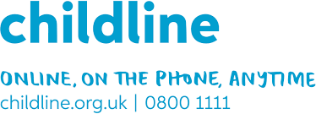 | Offer free advice, resources, online and phone support | https://www.childline.org.uk/  0800 1111
 | Support and information. Online chat and support. | https://www.samaritans.org/  116 123
 | The Mix offers online support and over the phone support for under 25s | https://www.themix.org.uk/
 | Offering a Coronavirus Support Hub  One-to-one support, advice and guidance so young people can continue to develop confidence and upskill. | https://www.princes-trust.org.uk/help-for-young-people  0800 842 842
 | Online resources and support including YoungMinds Crisis Messenger text service providing free, 24/7 crisis support across the UK. | https://youngminds.org.uk/  https://youngminds.org.uk/find-help/get-urgent-help/youngminds-crisis-messenger/#youngminds-crisis-messenger  Text YM to 85258.
 | Offer advice and support for care experienced young people. | advice@becomecharity.org.uk.  0800 023 2033
 | Help at hand website for children and young people in care.  Free support, advice and information. | https://www.childrenscommissioner.gov.uk/help-at-hand/  0800 528 0731
 | The NHS also has a handy list of Apps you can access for support with wellbeing and mental health | https://www.nhs.uk/apps-library/category/mental-health/

