1. Go into Google

2. Click on Sign in

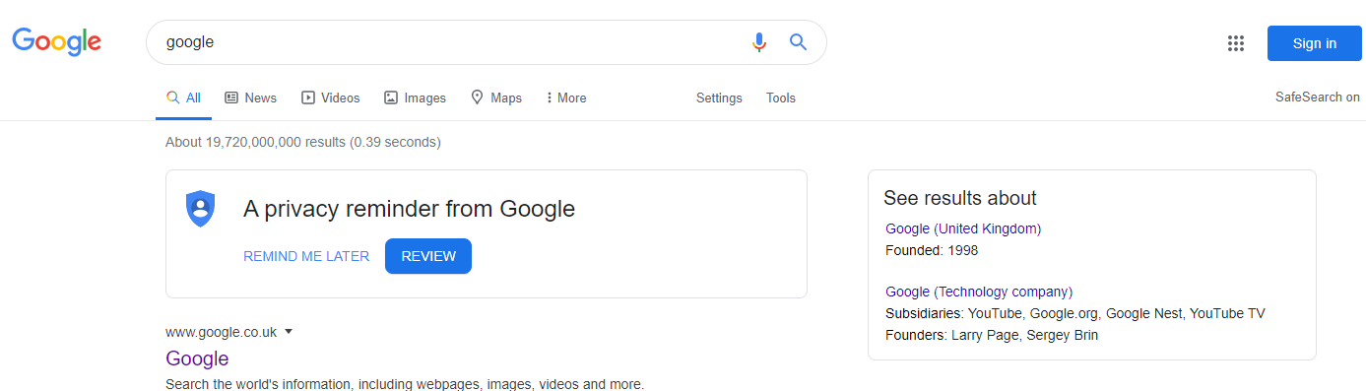

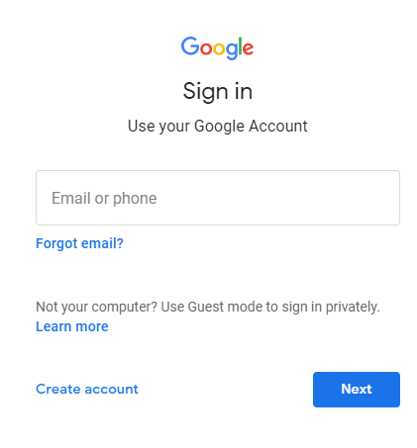

3. Your child will need to log in using their Google login. If your child is called Bill Smith their login would look like this:

b.smith22.316@agatemt.co.uk

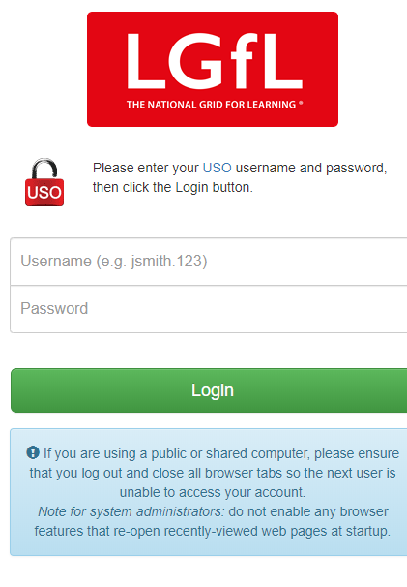

4. Your child will need their login again and their password:

b.smith22.316

password

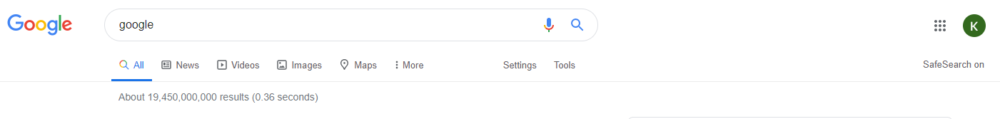

5. Click on the waffle. Then find Classroom

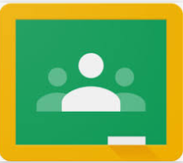

6. Your child should then be able to find their class.

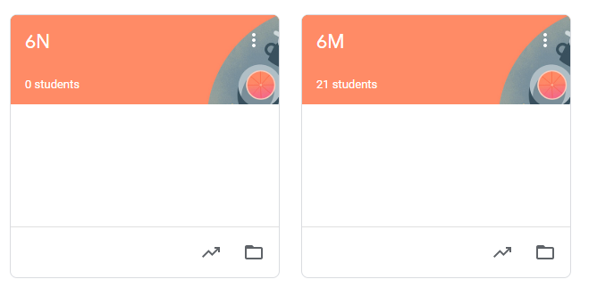

7. Click on Classwork. Your teacher will leave instructions here.

